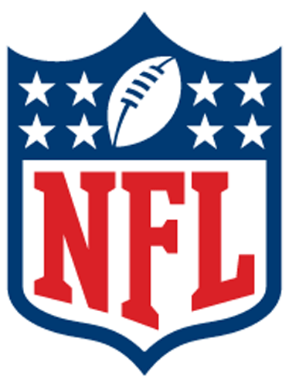


Manager of
Honor for Awarded to…
Congratulations and thank you for your part in making CNFL one of the best fantasy football leagues around.

